The Impact of Population Aging on Public and Private Economic Flows,
NTA Working Paper WP15-04

Andrew Mason (corresponding author)
Department of Economics
University of Hawaii at Manoa, and
East-West Center
2424 Maile Way, Saunders 542
Honolulu, HI 96821
E-mail: amason@hawaii.edu

Ronald Lee
Departments of Demography and Economics
University of California
2232 Piedmont Ave
Berkeley, CA 94720
E-mail: rlee@demog.berkeley.edu

Diana Stojanovic
East-West Center
1601 East-West Road
Honolulu, HI 96848-1601
E-mail: dswongkaren@gmail.com

Michael Abrigo
Department of Economics
University of Hawaii at Manoa
2424 Maile Way, Saunders 542
Honolulu, HI 96821
E-mail: mmabrigo@gmail.com

December 7, 2015

The fiscal effects of demographic change vary greatly depending on a country’s position in the demographic transition as shown in Mason, Lee, et al. 2014 (2014). Demographic circumstances are favorable for public finances in many developing countries, and may well be for many decades, as a rise in the share of the taxpaying ages relative to the benefit receiving ages generates a fiscal dividend. Countries in these circumstances may have considerable flexibility to increase public spending, or to restrain growth in taxes, or to reduce public debt or to accumulate public assets. Eventually these countries will face the demographic conditions that are coming to dominate the developed world and some developing countries. In these countries the share in the high taxpaying ages is declining relative to the share of elderly who are the recipients of relatively large public benefits. This inevitably will lead to a tightening of public sector budget constraints requiring tax increases, a retrenchment of public support, and/or rising public debt.
The attractiveness of policy responses to aging can only be adequately assessed, however, by understanding private sector responses to any public policies pursued. Ultimately our interest is in how population aging will influence important economic goals like adequate investment in the next generation, reasonable living standards for the elderly, shared prosperity, and so forth. Public policy may encourage more investment in human and physical capital.
The objective of this paper is to provide a deeper understanding of the implications of aging for the public sector and policy options that respond to population aging. To do this it is essential to address the broader implications of population aging that affect both the public and private sectors and to understand how private sector decision-making may be influenced by decisions about the public sector.
Understanding the private sector is critical for two reasons. The first is that the private sector is subject to the same kinds of generational squeezes and resource imbalances that affect the public sector. Intergenerational transfers are governed by the iron law of transfers: a change in the number of givers relative to the number of receivers must be balanced by a change in the per capita transfer received relative to the per capita transfer given. The iron law of transfers affects transfers by parents (or grandparents) to children as envisioned in the Becker-Lewis Quantity-Quality model (Becker and Lewis 1973; Willis 1973). Similarly, the iron law of private transfers affects private transfers between adult offspring and their elderly parents.
The second reason the private sector is incorporated into the analysis is to extend our understanding of public policy beyond the implications for fiscal sustainability. Changes in public in-kind transfers have a direct influence on the welfare of different age groups because of the one-to-one relationship between public in-kind transfers and public consumption. Important examples are spending on public schools and publicly-funded health care. Cash transfers, notably pensions, and taxes influence the welfare of each age group or generation depending on how changes in resources influence consumption, saving, and transfers.

Model
The purpose of the model is to simulate how changes in age structure and public policy influence the allocation of resources across age groups or generations and among alternative uses: public and private consumption, public and private transfers, and public and private saving. The model provides a complete accounting of economic flows by age as formalized in National Transfer Accounts (Lee and Mason 2011; United Nations Population Division 2013).
The broad structure of the model is shown in Figure 1. Three of the four components of the model, the macroeconomic and demographic framework, the public sector, and public policy, are described in detail in Mason, Lee, et al (2015) and will be discussed only in broad terms here. The private sector model is described in more detail.
Demographic and macroeconomic conditions are treated here as essentially exogenous. Population by age, productivity growth, and the inflation rate are inputs to the simulation model. Real aggregate labor income depends on real productivity growth and the growth of the population weighted by age-specific values that capture age variation in labor force participation, unemployment, hours worked, and wages. GDP and asset income are assumed to grow at the same rate as labor income. The model incorporates the first demographic dividend but in other respects is not a growth model. Growth is not influenced by second dividend effects such as the impact of age structure on saving and investment or on human capital spending or school enrollment.
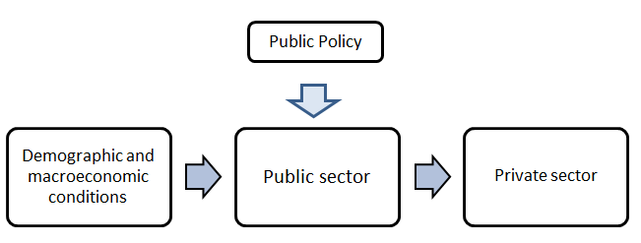
Figure 1. Structure of the model.
Public policy is introduced into the model using per capita age profiles of taxes and public transfer inflows. The profiles are normalized on the labor income of adults 30-49. Under the status quo scenario, the age profiles shift upward in real terms with real productivity growth or in nominal terms with nominal productivity growth. If age structure were held constant over time, tax revenues and public spending would remain constant relative to aggregate labor income or GDP over time.
Public policy reform is introduced into the model by varying the normalized age profiles of taxes and public transfer inflows. In some scenarios, used for middle and low-income countries, public age profiles shift over time reaching a target profile when high income status is achieved. Two target profiles are used for this purpose – one based on social welfare states found primarily in continental Europe and a capitalistic profile similar to the US pattern. For many low and middle-income countries these reforms lead to greatly expanded public sector roles, particularly social security programs for the elderly.
As their populations age countries which already have or which introduce extensive social welfare programs for the elderly will experience rapid growth in their public sectors relative to the size of their economies. They may also experience large deficits and growing public debt. In the simulations, public policy responses to these possibilities are limited by constraints on the size of government and public debt. For example, in one set of scenarios we assume that public transfer inflows can not exceed 45 percent of GDP and the public debt cannot exceed 90 percent of GDP. The constraint on size of government is hard in the sense that it is met through an immediate reduction in public transfer inflows and taxes. The debt constraint is soft and met over an extended period of time.
The final policy scenario considers a very special form of reform that explores the potential from tying public policy to a health-related concept of aging. In these scenarios, we adjust public transfer inflows, taxes, and labor income profiles as life expectancy improves.
The public sector component of the simulation model is essentially an accounting exercise. Demographic and macroeconomic data are combined with NTA age profiles to calculate aggregate taxes, public consumption, public transfers, public asset income including interest expense, and public assets/debt. The public sector model also distinguishes spending for public education, health, pensions, and other purposes.

The private transfer system
The key innovation in this model is the treatment of the private sector and its responses to changes in age structure and public flows. Changes in population age structure have both income and substitution affects that will influence the allocation of resources. A rise in the share of the working-age population produces a positive income effect or a demographic dividend at the family level. Saving and/or consumption for every family member can be raised. NTA tracks flows across age groups including flows within families so, if parents age x have fewer children, consumption and saving by age group x would be expected to rise. Transfers to the elderly would rise to, as well. Total transfers to children would be expected to decline but by less, in percentage terms, than the decline in the number of children. In this fashion, standards of living of all family members would rise as well as future standards of living.
Changes in age structure may have a price effect in addition to an income effect. If families have fewer children, then the price of achieving a given quality, as measured by expenditure per child, is reduced. This idea is familiar at the micro level in the quantity-quality tradeoff concept introduced by Becker and Lewis, Willis, and others.
To some extent the same ideas translate to thinking about transfers to the elderly and change in the old-age support ratio. Through an income effect, we would expect that a rise in old age dependency would lead, among households that support the elderly, to a decline in consumption, saving and transfers to children and a rise in transfers to the elderly, but one smaller in percentage terms than the increase in the number of elderly dependents. Again, there may be a price effect in that the cost of maintaining per capita spending among elderly dependents is raised, if there are more per household to support. Elderly, unlike children, are givers as well as receivers of family support. Hence, changes in age structure will influence their decisions (for example, about transfers to grandchildren) as well as the decisions of their offspring.
An overview of the nature of private transfer systems is very useful to understanding the approach employed to modelling them discussed in more detail below. Private transfers are a critical resource or inflow for children and the elderly, but they are also important for prime age adults. For adults, but not children, private transfers are a very important use of funds. The importance of inflows, outflows, and net flows can be seen in Figure 2 which shows private transfer inflows and outflows relative to private consumption for India by single year of age in 2005 (Note that in this diagram, the denominator in the ratio is specific to each age, unlike our usual standardization by labor income at ages 30-49). For children, private transfer inflows were more than sufficient to fund all of their private consumption since the transfers must also fund value added tax on the goods consumed by children. At older ages private transfer inflows also rise to high levels about equal to private consumption for those 90 and older. But we see that even prime age adults receive substantial private transfer inflows. At a minimum private transfer inflows were equal to 48 percent of private consumption for those of age 52 in India.
The costs of the private transfer system fall most heavily on middle-aged adults, but young adults and the elderly also have large private transfer outflows relative to own consumption. Private transfer outflows exceed private consumption between the ages of 33 and 71 inclusive and peak at 152% of private consumption at age 45.
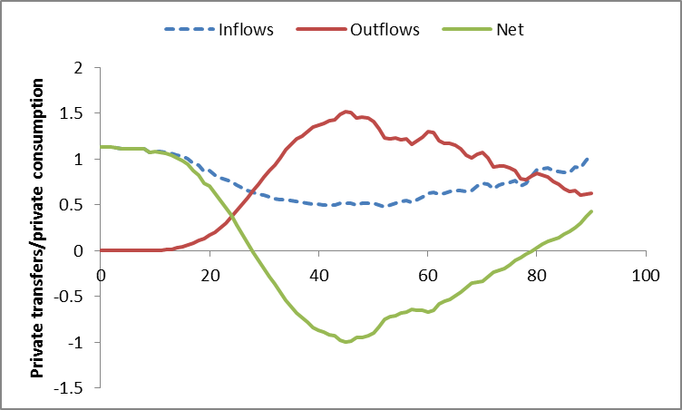
Figure 2. Private transfer inflows and outflows relative to private consumption by age, India, 2005.
Net private transfers (inflows less outflows) are positive for those 27 or younger and 80 and older. The magnitudes involved are substantial at many ages. Net private transfers exceed private consumption for children at most younger ages. Net private transfers to the elderly do not reach that level, however. They do not reach a third of private consumption until age 89. The costs of providing intergenerational support are substantial for many working-age adults. Those between the ages of 34 and 54 have net outflows that exceed 50 percent of private consumption. The maximum burden occurs at age 45 when net private outflows equal 99.7% of private consumption.
The effect of changes in population age structure on private transfers will depend on the specifics of the cross-age linkages in the private transfer systems. A rise in child dependency, for example, will not affect all working-age adults equally, because the private transfer inflows are governed by a network across age groups dominated by personal, largely familial, connections. Family connections are very apparent in the full private transfer inflow outflow matrix for India for 2005 (Figure 3). The highest levels of transfers are represented by red and green, moderate transfers by deep blue, and low levels or none by the lighter shade of blue. These are aggregate flows from one age group to another including the flows between members of the same age group.
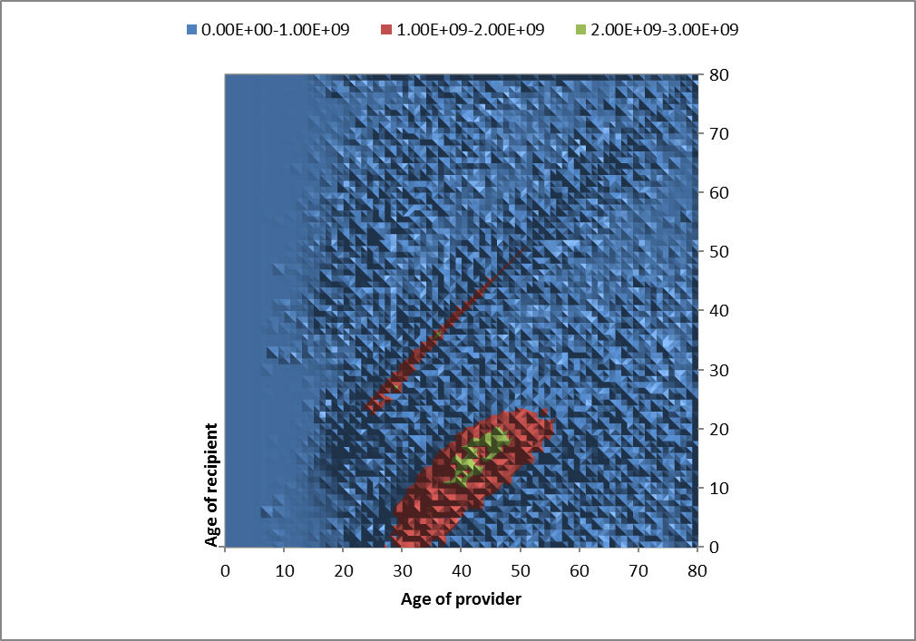
Figure 3. Aggregate private transfers (rupiah) by the age of provider and the age of the recipient, India, 2005. Note that this is projected for 2005 from the 2004 base year for which an estimate is available.
Because the magnitudes of the flows are aggregate values, they are influenced by the population in each age group. Relatively few Indians fall in the 80 and older range. Thus, flows to and from the elderly are less pronounced in Figure 3. Other prominent features of the private transfer matrix include the following. Private transfer inflows from children (under the age of 15) to others, noise aside, are zero. Transfers between similar age groups (along the principle diagonal) are substantial. These transfers are primarily between spouses, but would include transfers among siblings, as well. Transfers from adults (parents) to dependent children are also substantial, while transfers from adults to elderly parents are less prominent. Transfers from grandparents to grandchildren seem to be present but are diffused across many ages. Off-generation transfers, say between age groups separated by 15 or 45 years, are low.
Our approach to modeling private transfers relies on the private transfer matrix to identify three factors that influence the resources provided by age group x to age group y. The first is population age structure. Transfers given by age group x depend in part on the number of individuals in each receiving age group y relative to the number or providers in age group x. Age structure is incorporated using N(y)/N(x).
The second consideration is the relative cost of age y recipients. Are the per recipient inflows large or small relative to the resources of the age x providers? This factor is measured as the private transfer inflow to age y recipients relative to the private consumption of those age x. Figure 4 shows the values for 2005 India for providers of age 40.
The relative cost for children is closely related to the equivalent adult consumer unit because, for children, private transfer inflows and private consumption are very similar. Private consumption by young children was about 40 percent of the private consumption of forty-year-olds (or other prime age adults). That cost rises as children reach prime ages because their consumption is rising and, hence, the costs to adults in terms of private transfers are rising. To the extent that children are supporting themselves rather than depending on others, the costs to others are moderated. The rise in self-sufficiency in adulthood leads to a decline in the relative cost of recipients after about age 20. Then we see a steady rise in relative costs after age 40. The private transfer inflows reach very high levels for the elderly. Private transfer inflows are not closely tied to consumption at older ages, however, because adults have other sources of income and other uses beside consumption.
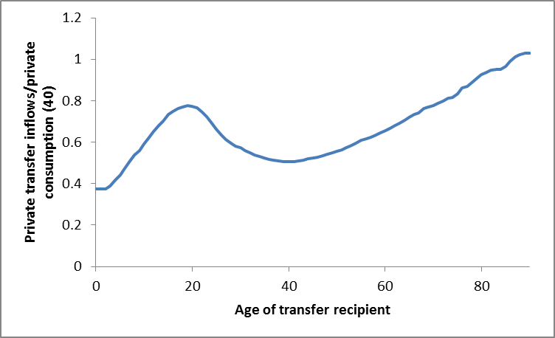
Figure 4. Relative cost: private transfers inflows by age of recipient relative to private consumption at age 40, India, 2005.
The third factor captures how the private transfer costs are shared among each age group of providers. This factor is incorporated into the model using the share of total private transfers received by persons age y provided by persons of age x. The age distributions of providers for private transfer recipients at four ages for India in 2005 are shown in Figure 5 constructed using the private transfer matrix shown in Figure 2. For 10-year-olds in Panel A, the flows are heavily concentrated and centered at around age 40. These children receive some transfers from the elderly (grandparents) but the age distribution of flows from grandparents is more dispersed than the age distribution of flows from parents.
Young adults, twenty-five-year-olds in panel B, depend on members of the parent generation but also heavily on own generation transfers. Prime age adults, age 45 in panel C, depended heavily on members of their own generation and to a much more limited extent their children and perhaps their parents. And seniors (panel D) depend most on their own generation but receive substantial transfers from the generation of their direct descendants.

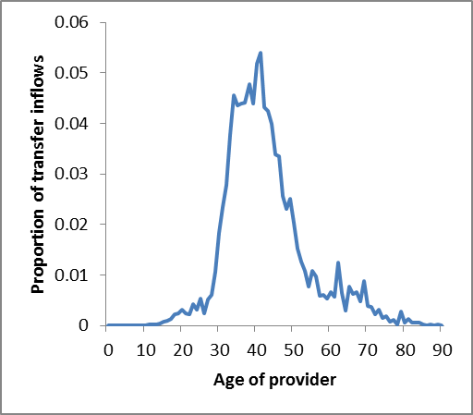  A | 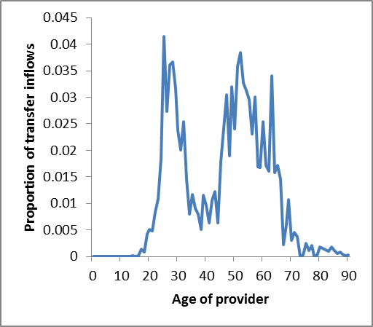  B
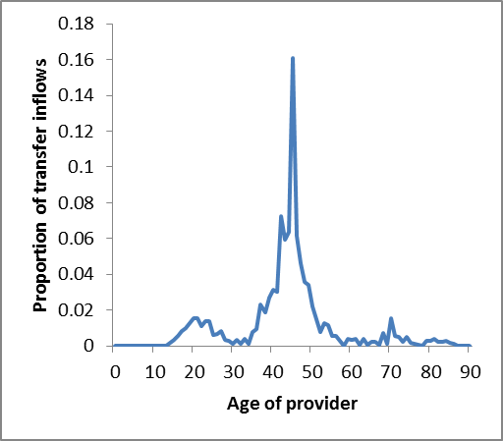  C | 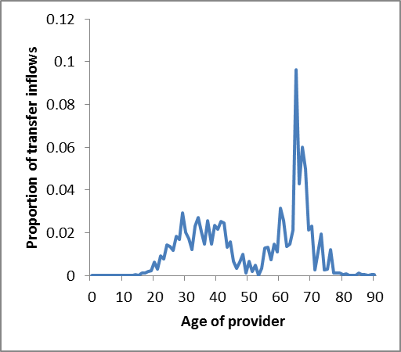  D
Figure 5. Private transfer inflows by age of provider as a proportion of total private transfer inflows to 10-year-olds (A), 25-year-olds (B), 45-year-olds (C) and 65-year-olds (D). India, 2005.

The structure of the private transfer system will also dictate how changes in public transfer inflows and taxes influence standards of living and welfare of every generation. An increase in cash transfers or a decrease in taxes leads to income effects that influence consumption, saving, and transfers to those with family connections. The change will work its way through the family support system until an equilibrium is re-established. Depending on the nature of the family support system, public sector responses may have large or relatively modest effects on the intergenerational distribution of resources.

Private sector model
The private sector problem is as follows. Each age group is subject to a resource constraint that outflows, or resource uses, cannot exceed inflows which consist of labor income, private asset income, public cash transfer inflows, private transfers from residents, and net private transfers from the rest of the world. Labor income depends on age and exogenous productivity growth. Total private asset income is equal to the difference between public asset income, determined in the public module, and total asset income which is a constant share of GDP. We make no explicit assumption about whether public debt is held domestically or by the rest of the world, but suppose that public debt were held by residents. The assumption of fixed total asset income would imply that the increase in private debt would be matched by an increase in private credit held by households. Privately owned capital is not affected by changes in the extent to which the public sector is borrowing from the private sector. The age pattern of private asset income is fixed based on NTA data, and the level varies depending on the age distribution of the population and total private asset income. Public cash transfer inflows are primarily public pension inflows determined in the public sector module. Net private transfers from the rest of the world assumed to be constant relative to GDP. Private transfer inflows are endogenous and determined jointly with outflows through a non-market equilibrating process.
Using upper case to represent aggregate values, inflows to persons age x in each period are given by:
Using lower case to represent per values, we also have:
where infl(x,t) are the inflows from all sources to persons age x in year t and the sources are: yl(x,t) labor income; yaf(x,t) private asset income; tgicash(x,t) public cash transfer inflows; tfi_d(x,y,t) private transfers inflow received from residents age y; and tf_drow(x,t) net transfers from the rest of the world.
Subject to the inflow constraint, each age group, 0 to 100+, must allocate resources among four broad uses: per capita private consumption (cf), per capita private saving (sf), per capita private transfers to residents (tfo_d), and taxes. Taxes are pre-determined in the public sector module and, hence, assumed to be independent of the allocation amongst the remaining uses. The allocation of consumption among competing ends (health, education, and other) is assumed to be separable. Transfers are distinguished by the age of the recipient, ranging as well from 0 to 100+. Outflows for each age x=0,100+ are given as:
In per capita terms, we have:
The members of each age group are subject to a resource constraint that outflows cannot exceed inflows (INFL). Inflows consist of labor income (yl), private asset income (yaf), public cash transfer inflows (TFICash), private transfers from residents (tfi_d), and net private transfers from the rest of the world.
The solution to the private sector problem must satisfy the following restriction. First, outflows are equal to inflows at every age x=0.100+:
Second, total private transfer inflows received by persons age x given by persons age y must equal total private transfer outflows given by persons age y to persons age x:
Third, for all ages combined transfer inflows plus net transfers to the rest of the world must equal transfer outflows:
The structure of the private sector allocation problem is captured by the inflow-outflow matrix shown in Table 1.

The allocation of resources to private transfers relative to private consumption depends on the three features of private transfers systems described above: population age structure (N(y,t)/N(x,t)), the share of transfer inflows to age group y born by age group x (w(y,x,t)), and the magnitude of private transfer inflows to age group y relative to age group x (tfi_d(y,t)/cf(x,t)):
Equation has a number of interesting properties. Per capita transfers given relative to own-consumption are unaffected by changes in overall prices and changes in population size, but not age structure. A doubling of the receiving population relative to the providing population leads to a doubling of relative transfer outflows.
Summing across the age of recipients yields private transfer outflows relative to private consumption by the age of providers (DRF(x,t)):

In any period t, per capita after tax private outflows for each age group is the sum of private consumption, private saving, and private transfer outflows to residents:
We assume homothetic preferences, so that the share of disposable income devoted to consumption, saving, and private transfer outflows are unaffected by changes in income. The ratio of private saving to private consumption will equal the value in the baseline:
The ratio of private transfer outflows to private consumption is equal to the age-specific private dependency ratio defined above:
We can re-write per capita outflows by substituting in equation :

Solving for private flows
The system of private flows is under-identified and has no unique solution. We rely on an iterative method similar to a method used by demographers (referred to as the Deming method by them) and by economists (referred to as bi-proportional adjustment by them). The method has been shown to have many attractive features and has been widely used in a number of specialized applications, such as, adjusted cross-tabulated data to match marginal values and to project input-output tables (Deming and Stephan 1940; Bacharach 1965; Lahr and de Mesnard 2004).
The basic approach can be understood with reference to the TFIO inflow-outflow matrix in Table 1. Suppose that the row and column totals, inflow and outflows by age, are “known,” but they are inconsistent with the joint distribution. This could arise, for example, because the row and column totals, the marginal, have been adjusted. They might have been smoothed or they might have been adjusted to incorporate revised population data. Bi-proportional adjustment involves iteratively adjusting the values in the inner matrix. First, all values in each row are scaled upward or downward (multiplied by an adjustment factor) to match the “known” row total. Then all values in each column are scaled to match “known” column total. Then the values are adjusted to match row totals and then the column values to match the column total. This process is repeated until both the rows and columns values match the “known” row and column totals.
The procedure employed here is very similar to bi-proportional adjustment but differs to incorporate the more complex responses to changes in private transfer outflows to responses in population age structure embodied in equation . In the iterative procedure employed we iteratively compute per capita transfer and aggregate inflows and outflows adjusting the inflow-outflow matrix and recalculating the endogenous variables until convergence criteria are satisfied. The details of the method are described in Mason et al (2015).

Results
Simulations of the public and private sectors have been carried out for nine countries which vary widely in their levels of development, their demographic conditions, and their public sectors. Comparative results are presented in a paper under preparation. Here we look in more detail at two countries, first India and then Japan.
India is considered an early dividend country (World Bank 2015). Its fertility rate has dropped steadily over recent decades and is nearing replacement level. The share in the working ages is expected to increase over the coming decades. India’s demographic dividend is also being accompanied by a fiscal dividend. In the absence of changes to the structure of taxes and benefits in India, we would expect to see an increase in tax revenues relative to spending, a budget surplus, positive public saving, and the accumulation of substantial public wealth.
India could choose to proceed down this path, but it seems more likely that the public sector will play an increasingly important role, in part, because demographic conditions will be favorable for some time, and, in part, because development will lead to strengthened public capacity and a desire for more expansive social welfare programs. The prospects of population aging may dampen this shift, but aging also provides an impetus as increasing numbers of Indians anticipate old age.
We consider two approaches to reform of the Indian public sector. The first involves a more expansive approach to the public sector where public transfer inflows and taxes evolve slowly toward the current patterns of benefits and taxes found in a group of continental European countries. This is called the social welfare scenario and is contrasted with a capitalistic scenario, a less expansive approach where benefit and tax profiles approach those similar to values found in the United States. In both cases, the reform scenario begins in 2020 and is completed when India is projected to reach upper-income status near the end of this century.
In the early years (dark green) tax revenues are relatively constant while public transfer inflows decline as a consequence of declining child dependency. Under the status quo scenario, taxes and spending both begin to rise moderately as a share of GDP around 2045. Under the reform scenarios, taxes and spending rise much more sharply – particularly in the case of the social welfare scenario. By the end of the simulation public transfer inflows are approaching 25 percent of GDP under the capitalistic scenario and 40 percent of GDP under the social welfare scenario.
Initially revenues rise more rapidly than expenditure under either reform. This occurs in a mechanical sense because the reform tax profiles are more heavily concentrated at the working ages than the status quo profile. But this also reflects an important feature of social security programs – heavy reliance on earnings taxes. Start-up phases of these programs often lead to the accumulation of public assets a phenomenon we see in the India simulations.
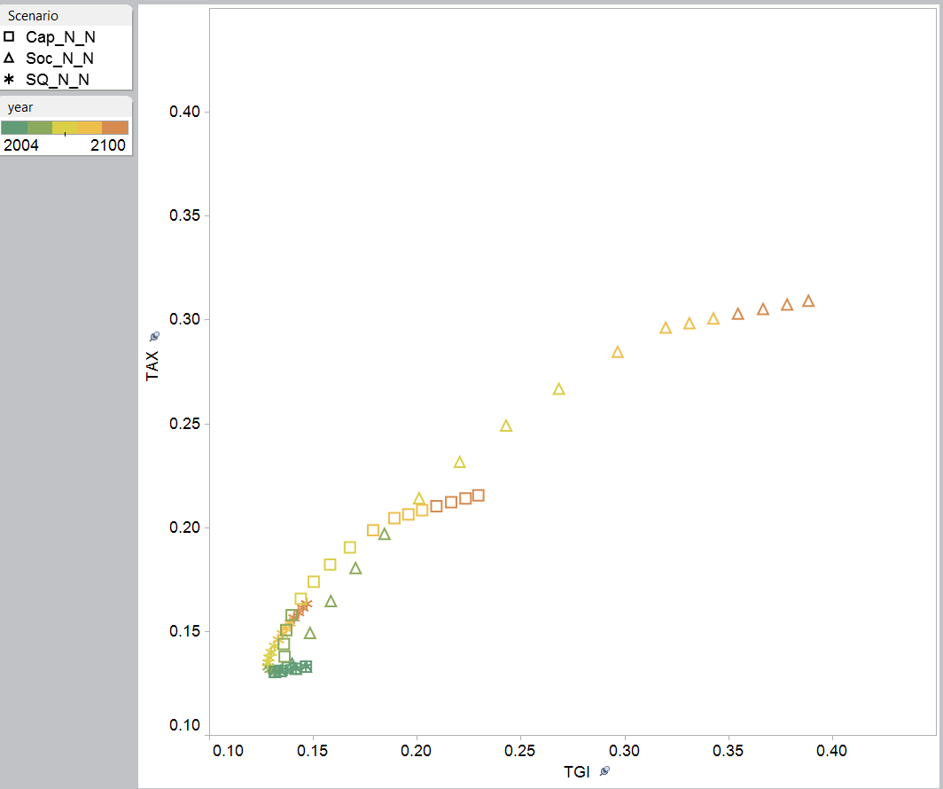
2004
TGI > TAX
TAX > TGI
Figure 6. Taxes (TAX) and public transfer inflows (TGI) as a share of GDP, India, 2004-2100, three scenarios: capitalistic (Cap), social welfare (Soc), and status quo (SQ). No constraints on government size or indebtedness (_N_N).
The fiscal dividend represents an opportunity but also a trap. From the perspective of public finances, any of the scenarios poses no problem for decades to come. The phase in of social welfare programs for the elderly combined with favorable demographics generated surpluses, high rates of public saving, and the accumulation of public assets. In 2010, India’s public debt was equal to about 30 percent of GDP, but it is paid off by 2035 or 2040 under any scenario. Problems begin to appear only under the social welfare scenario and not for many decades. Public asset reach a peak of 55 percent of GDP in 2065, but decline sets in thereafter. Public saving turns negative after 2075 and public assets are gone by 2095.
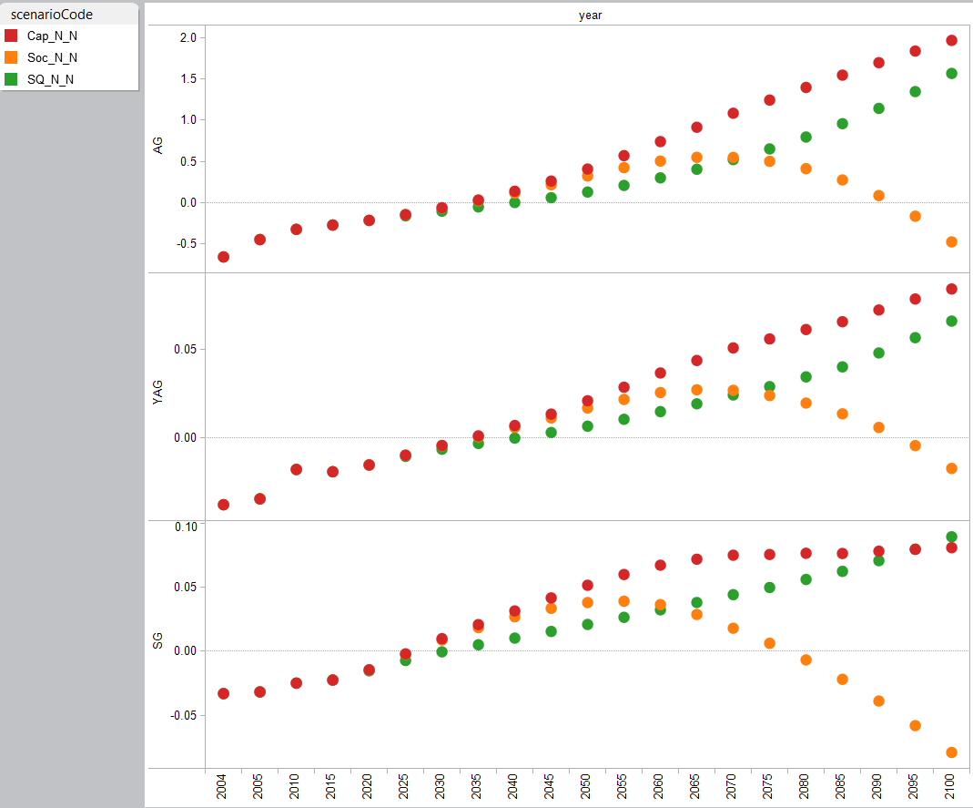
Figure 7. Public sector finances, India, 2004-2100, three scenarios. Public assets (AG), public asset income (YAG), and public saving (SG) reported as a proportion of GDP. Capitalistic scenario (Cap), social welfare scenario (Soc), and status quo scenario (SQ) reported with no constraints on the size of government or indebtedness (_N_N). See text for explanation.
The reform scenarios have a major effect on public intergenerational transfers. This can be seen in Figure 8 which reports public flows by age normalized on the mean labor income of persons 30-49 in 2050 under the three scenarios. Public consumption (equal to public in-kind transfer inflows) is highest for children (education) and the elderly (health care) under the social welfare scenario and lowest in the status quo scenario. Prime-age adults have similar in-kind transfer inflows for all scenarios. Cash transfers are highest for the elderly but also rise for prime age adults under the social welfare scenario. Cash transfer inflows begin to rise at a younger age under the social welfare scenario than the capitalist scenario. Cash transfers are lowest for prime age adults and intermediate for the elderly in the capitalist scenario. Taxes are highest at all ages for the social welfare scenario except at very old ages where the highest tax burden occurs under the status quo scenario. Importantly the higher taxes under the reform scenarios fall heavily on prime age adults. Either reform scenario increases disposable income for the elderly relative to prime age adults. Children enjoy greater in-kind transfers under the reform scenarios but are not directly affected in other ways.
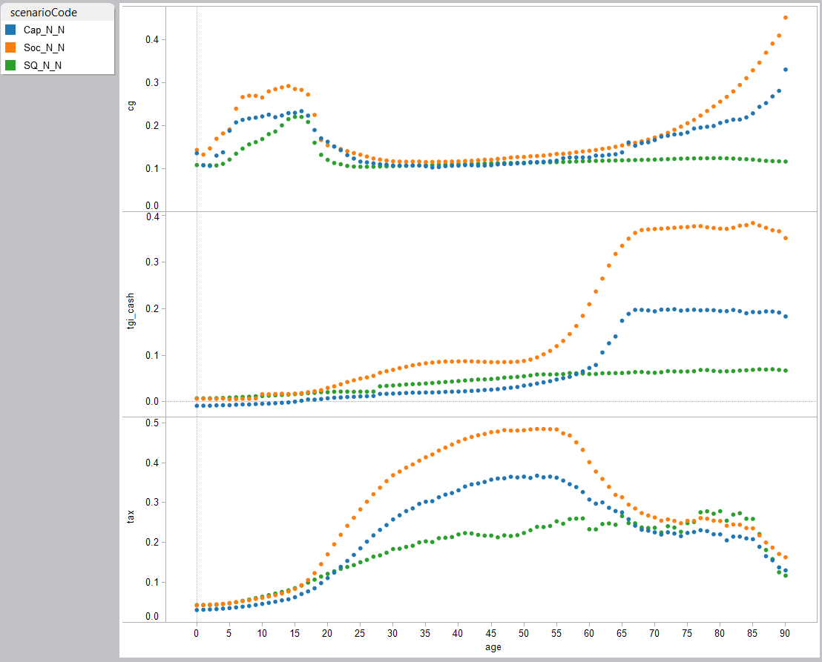
Figure 8. Public consumption (cg), public cash transfers (tgi_cash), and taxes (tax) by age, India, 2050, three scenarios. All values normalized on the average labor income of persons 30-49. Capitalistic scenario (Cap), social welfare scenario (Soc), and status quo scenario (SQ) reported with no constraints on the size of government or indebtedness (_N_N). See text for explanation.
The generational distribution of resources is also affected by population aging because per capita private asset income by age declines over time. The decline is similar for all scenarios and is substantial – about a 30 percent drop between 2015 and 2050. This has a greater impact on the elderly because they depend much more on private asset income and much less on labor income than younger adults. Hence, the intergenerational shift in public transfers is offset to some extent by the intergenerational shift in primary income (labor plus private asset income).
Simulated private transfers respond to public policy in ways to be expected (Figure 9). Private transfer outflows from the elderly are larger and inflows are smaller so that net transfers to the elderly are reduced as net public transfers to the elderly increase. This is offset by reduced (less negative) net transfers from prime age adults. Net private transfers to children are somewhat smaller under the reform scenarios. Transfers from grandparents may be larger but more than offset by a decline in transfers from parents. The private transfer responses to the social welfare and capitalistic scenarios appear to be quite similar.
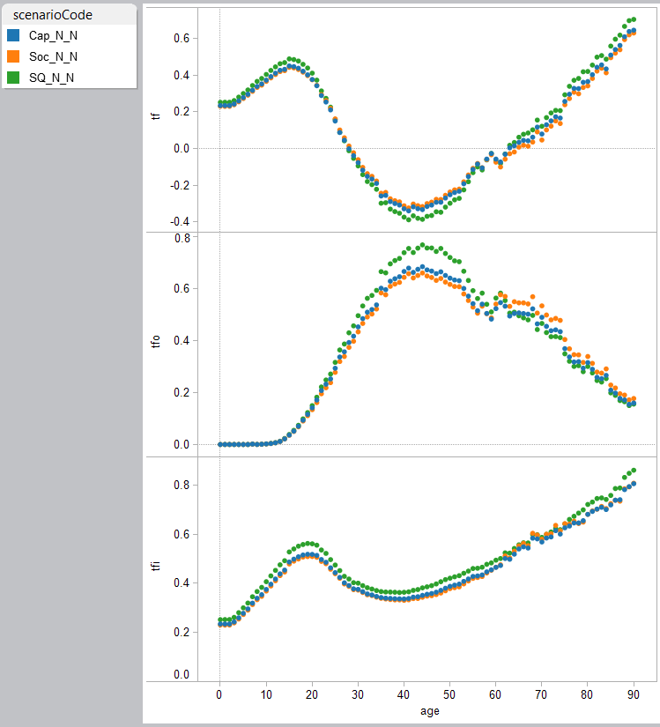
Figure 9. Private transfers by age, India, 2050. Net private transfers (tf), private transfer outflows (tfo), and net private transfer inflows (tfi) are normalized on the per capita labor income of persons 30 to 49. See previous figure for explanations of three scenarios.
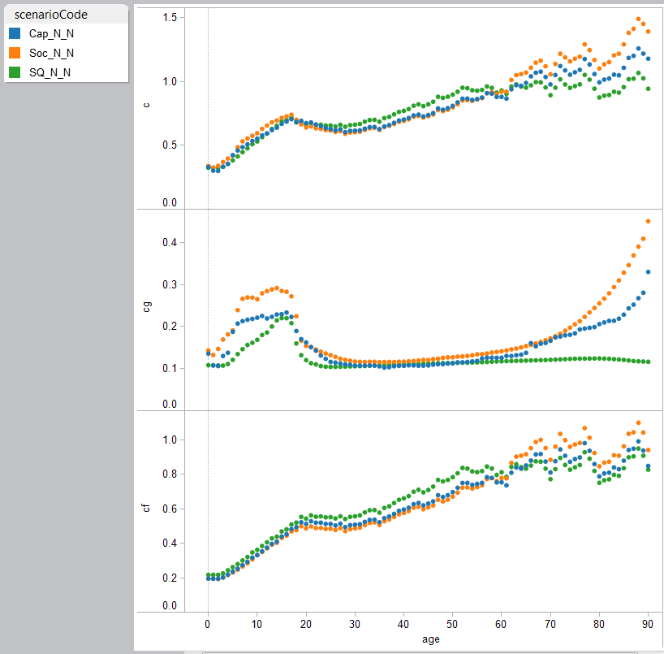
Figure 10. Consumption by age, India, 2050. Consumption (c), public consumption (cg), and private consumption (cf) are normalized on the per capita labor income of persons 30 to 49. See previous figure for explanations of three scenarios.
Either reform reduces consumption of prime age adults and raises the consumption of the elderly as compared with the status quo scenario (Figure 10). The elderly are particularly favored by the social welfare reform scenario. Both public and private consumption for the elderly rise. The outcome for children is mixed. Public consumption is much higher under the reform scenarios, but private consumption is somewhat lower than under the status quo scenario.
High consumption relative to labor income under the social welfare scenario may at first glance appear to be an attractive feature. However, higher consumption is not realized here by faster economic growth. It is solely a consequence of reduced aggregate saving. This can be seen by comparing the trends in aggregate saving rates (net saving as a share of GDP) under the three scenarios (Figure 11). Under any of the scenarios saving rates are rising for some time. They increase from 22 percent of GDP in 2004 to over 30 percent of GDP by 2050. The greatest increase over this period is in public saving which is crowding out private saving to some extent. By 2050 saving rates have begun to diverge as the public saving rates under the under the social welfare scenario begin to drop relative to the other scenarios.
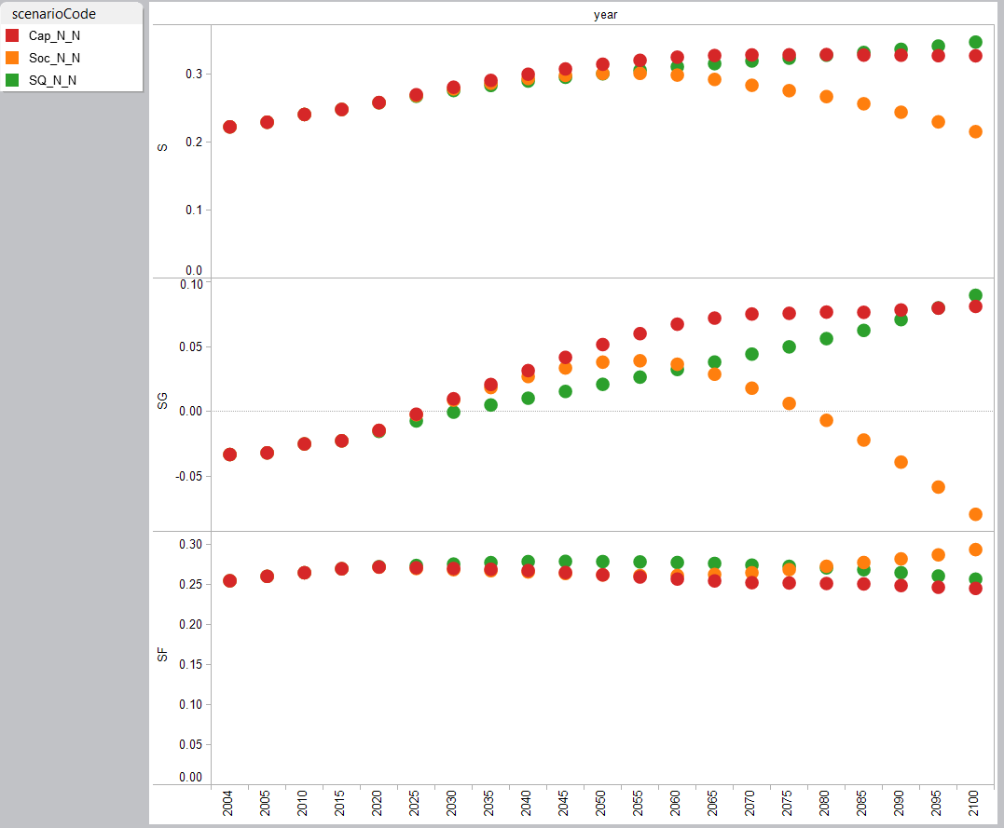
Figure 11. Saving rates, India, 2004-2100, three scenarios. Saving (s), public saving (sg), and private saving (sf) expressed as a share of GDP. See previous figures for an explanation of the scenarios.

Japan
Japan is different than India in many important ways. Per capita income is much higher in Japan. Economic growth is much slower in Japan and has been slow for decades. Japan has the oldest population in the world and more aging is coming. Japan has an extensive system of support for the elderly in place. Public finances are a problem as Japan is running a deficit and has a high debt to GDP ratio. Japan does, however, pay very low interest on its public debt.
The unconstrained status quo scenario is not an option for Japan. Given the current structure of taxes and benefits, Japan’s public debt would increase to five times GDP in 2050 and eight times GDP in 2090. The budget deficit would exceed one-quarter of GDP by 2055. We consider two possible reform scenarios. In one case, Japan would shift over an extended period of time (from 2020 to 2070) to a capitalistic system. This would entail a fairly substantial drop in public transfer inflows (Figure 12). Reform would reduce normalized taxes at almost all ages and particularly among those in the oldest working ages. Public transfer inflows would be cut substantially with particular large declines at young and old ages. In percentage terms, inflows for prime age adults would drop by as much as one-third. Net public transfers would drop at virtually every age.
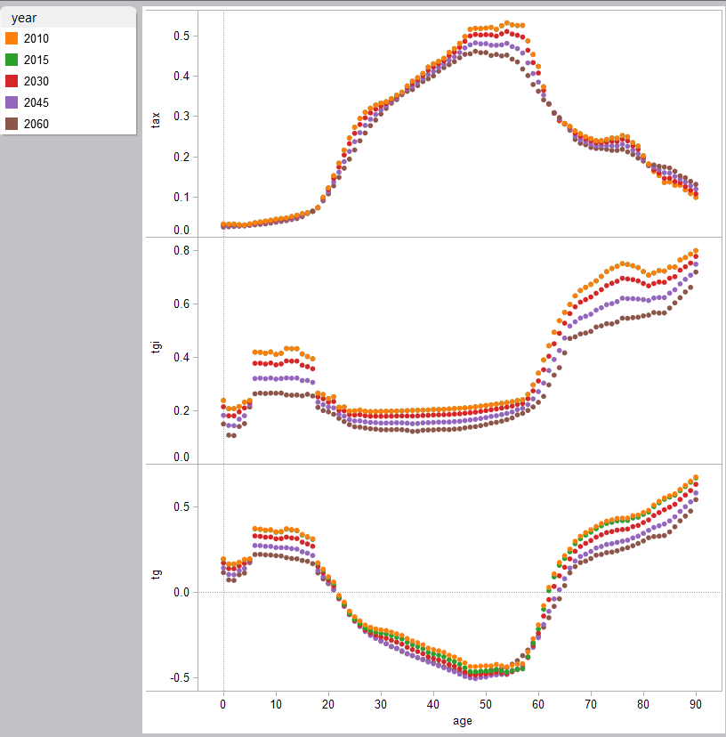
Figure 12. Reform scenario age profiles, Japan, 2010 to 2060. Taxes (tax), public transfer inflows (tgi), and net public transfers (tg) are normalized on the average labor income of persons 30-49.
Reform affects the age profile of taxes but has virtually no effect on total tax revenues. The changes in public finances come entirely from the spending side. Under the status quo scenario public transfer inflows would exceed 55 percent of GDP after 2055 while under the reform scenario public transfer inflows would peak at 45 percent of GDP in 2045 and then decline to just under 40 percent of GDP after 2065 (Figure 13). The reduction in spending would reduce the rate at which Japan was accumulating net public debt. Even with reform, net debt would exceed four times GDP by 2065. Thereafter, it would remain near that level while under the status quo scenario debt would continue to rise relative to GDP.

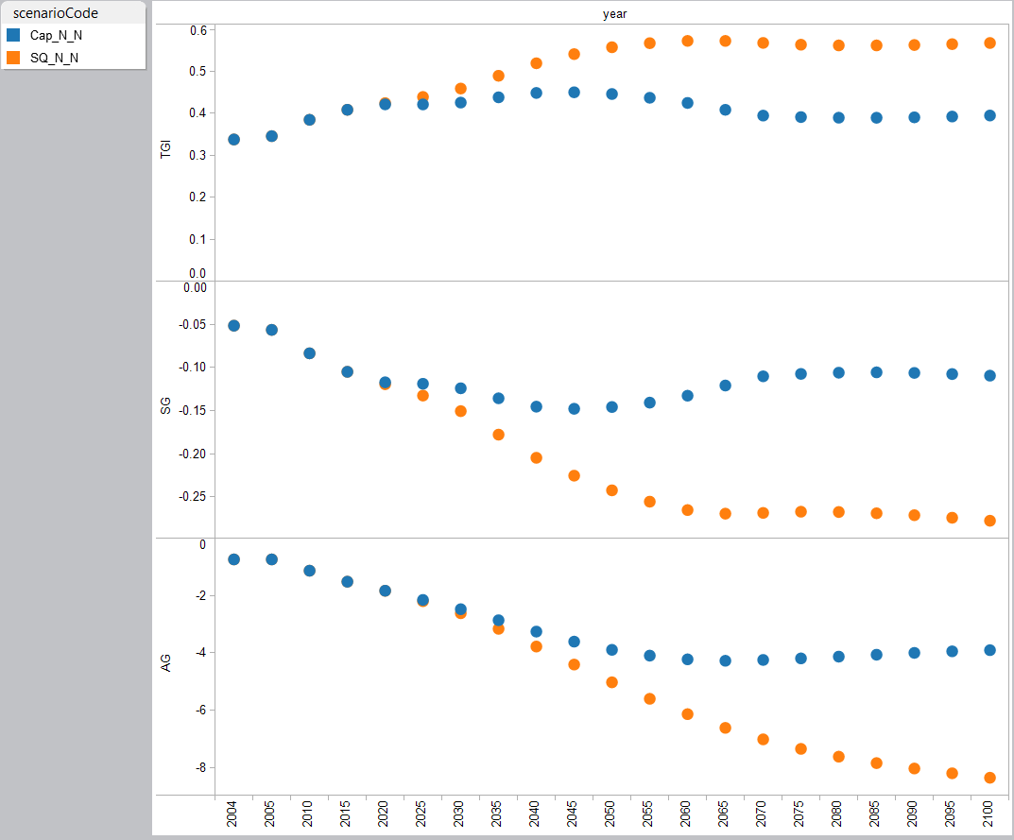
Figure 13. Public transfer inflows (TGI), public saving (SG), and net public debt (AG) as a share of GDP, Japan, 2004-2100 under two scenarios. See notes to previous figures.
Capitalistic reform offers a partial solution to Japan’s fiscal problems. It does not change the fundamental impact of aging. Given the social budget constraint and limits on debt, aging will lead to a decline in per capita consumption relative to labor income. As shown in Figure 14, the declines are substantial and affect all ages. Consumption at age 16 drops from 0.74 to 0.53 and at age 70 from 0.87 to 0.68 between 2010 and 2060. In absolute terms the changes are similar, but in percentage terms much greater for children. Prime age adults experience large declines, but certainly the pain is less than for children and elderly. At age 40, for example, consumption drops from 0.65 to 0.55.
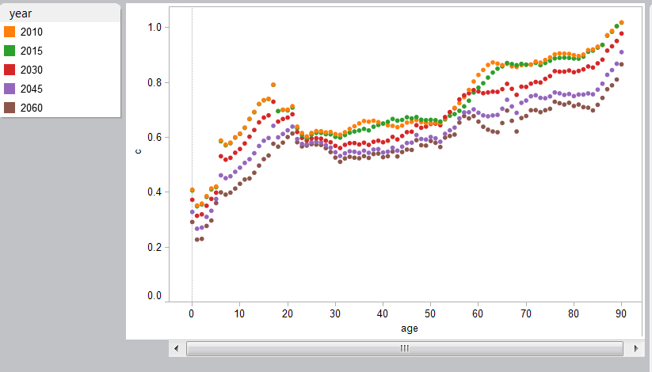
Figure 14. Per capita consumption by age, Japan, 2010 to 2060, capitalistic reform scenario. Consumption is normalized on average per capita labor income of persons 30-49.

Redefining age
A frequently discussed reform scenario is to sever the tie between public policy and age. If people are living longer and if they are healthier, perhaps they could work longer, pay more in taxes at older ages, and on average delay their dependence on public transfers that support health, long-term care, and other programs for the elderly. There is very little experience with these kinds of programs and it is very unclear what kinds of policies would be required to induce workers to delay retirement. Nor is it entirely clear to what extent we might expect growth in health care spending to be curtailed by improvements in health and delayed mortality (refs here to Miller and others).
We use a simple approach to considering the potential for such programs by tying three relevant age profiles, labor income, taxes, and public transfer inflows, to survival rates (as a proxy for health) rather than to age per se. (The details for implementing this are described in Mason, Lee, et al. 2015.) The consequences of this “policy” for labor income, taxes, and public transfer inflows are shown in Figure 15. Over the 50 year period plotted, the per capita age profiles shift to right by more than one year of age for every decade. For example, labor income drops to about 0.5 at age 62 in 2010. By 2010, labor income of 0.5 is reached between the ages of 70 and 71.

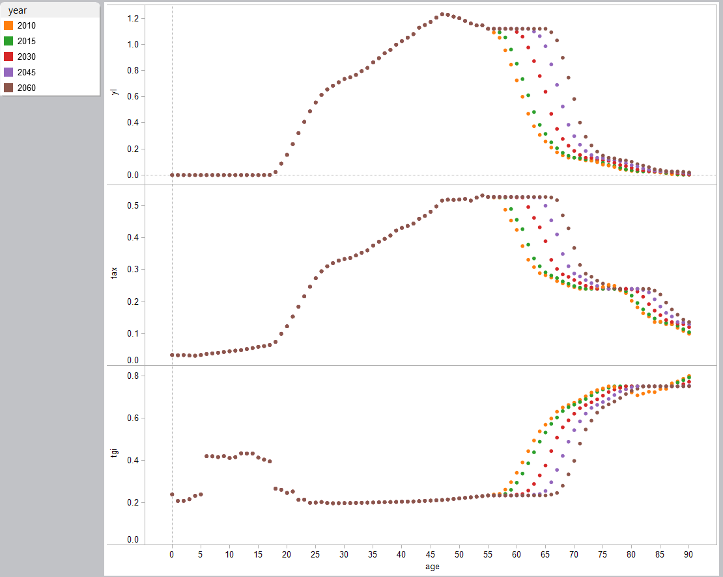
Figure 15. Redefining old age. Per capita labor income (yl), taxes (tax), and public transfer inflows (tgi), by age, Japan, 2010-2060. See text for explanation.
The policy curtails the growth of benefits in Japan and maintains tax revenues during the coming decades (Figure 16). Between 2040 and 2060, public transfer inflows peak at just over 40 percent of GDP. Tax revenues remain steady from 2010 onward between 30 and 32 percent of GDP. The large gap between taxes and spending leads to steady growth in net public debt which rises from 100% of GDP in 2010 to 330 percent of GDP in 2060. This is a considerable improvement in public finances over the status quo scenario. By itself, however, it does not resolve Japan’s fiscal problems.

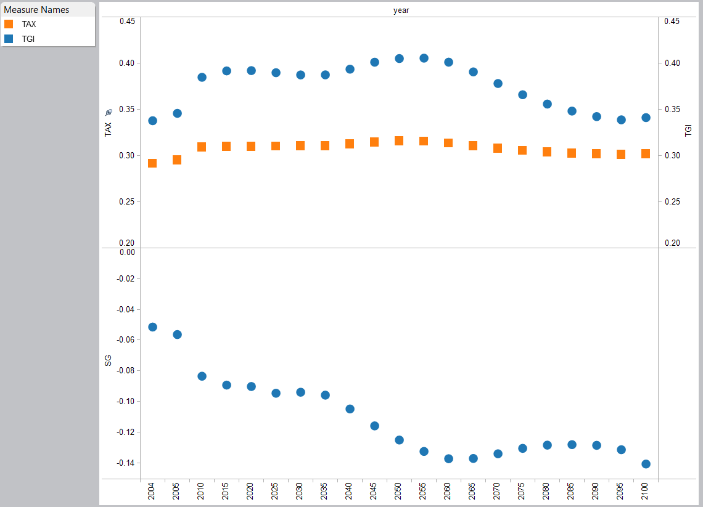
Figure 16. Public finances in Japan with survival linked public policy, 2004-2100. Taxes (TAX), public transfer inflows (TGI), and public saving (SG) as a share of GDP.
The potential for this kind of policy seems to be promising as judged from the simulated normalized consumption profiles (Figure 17). On the whole, the level of per capita consumption is maintained throughout the simulation. Consumption by children does not decline at all. Normalized consumption by prime age adults does decline by as much as 8 percent between 2015 and 2030. Consumption rises for those most affected by the policy. Between 2015 and 2045 there are substantial gains in consumption among those in their late 50s and early 60s. After 2045 we see increases at more advanced ages.
Note that these gains presume real success at raising labor income at older ages. It is unclear what kinds of policies would be needed to realize these kinds of gains, but surely more than raising the retirement age is required. A problem that is particular serious in Japan is its continued reliance on seniority based wages. To the extent that high wages at older ages do not reflect productivity extending the work life will not produce the gains in GDP that are essential to realizing the favorable effects described here.
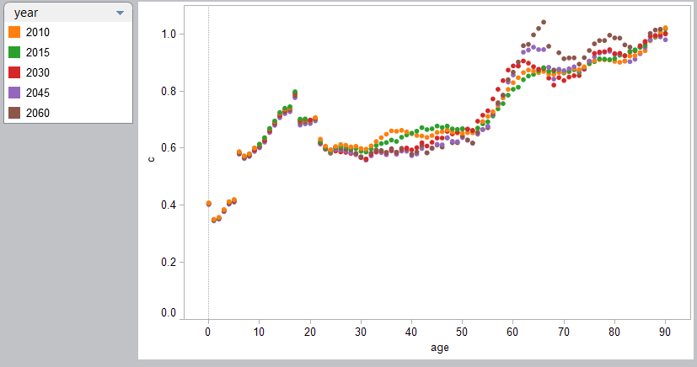
Figure 17. Per capita normalized consumption by age, Japan, 2010 to 2060, survival linked policy scenario.

Conclusions
Changes in population age structure have profound implications for the public sector but, more importantly, for standards of living. Demographic conditions have been favorable for public finances and standards of living in most countries in the world for many decades. This is changing, however. High income countries are post-demographic dividend countries and face substantial population aging in their immediate futures. Japan represents one end of a continuum. It has the oldest population in the world and it is experiencing population decline. Its public finances are unfavorable and it faces further deterioration. Neither of the reform measures considered here is sufficient by itself to provide a remedy for its debt problems, although both offer substantial improvements and taken together might offer a path out of current difficulties.
Comparing the two scenarios for Japan illustrates an important point. If a large and increasing share of a country’s population is not productively employed, no policy can avoid a declining material standard of living as measured by per capita consumption. On the other hand, a vigorous and successful policy that mobilizes older adults can have a surprisingly powerful impact. Is the kind of outcome described here possible? And what policies would be needed to achieve it? These are questions that we cannot answer.
The prospects for advanced aging countries may not be as bleak as the scenarios presented here for Japan suggest. None of the analysis considers how changes over the age transition influence productivity. In a number of studies we have discussed the possibility of a second demographic dividend as low fertility and population aging lead to greater investment in human and physical capital (Mason and Lee 2007; Lee and Mason 2010).
For many countries in the world, including India, the demographic dividend is ongoing. Changes in population age structure are leading to a fiscal dividend that will allow a more expansive and valuable role for the public sector. Social welfare programs serve an important function and increasingly so in countries that will eventually have a much larger old-age population.
The simulations for India consider two alternatives that envision “full service” public sectors by the time that India reaches high income status. The social welfare scenario envisions a more expansive role for government and intergenerational public transfers, while the capitalistic scenario conforms to a smaller public sector. In the medium term, either of these approaches appears equally feasible. It is only when we take a much longer view than is typical do we see substantial differences between the two approaches. Issues of sustainability become apparent only after many decades (or in the more immediate prospects for Japan). This analysis supports the view that public intergenerational transfer programs need to be approached with caution. They provide critical value, but they also are a potential trap.

References
Bacharach, M. (1965). "Estimating Nonnegative Matrices from Marginal Data." International Economic Review 6(3): 294-310.
Becker, G. and H. G. Lewis (1973). "On the Interaction between the Quantity and Quality of Children." Journal of Political Economy 81(2): S279-288.
Deming, W. E. and F. F. Stephan (1940). "On a Least Squares Adjustment of a Sampled Frequency Table when the Expected Marginal Totals are Known." The Annals of Mathematical Statistics 11(4): 427-444.
Lahr, M. L. and L. de Mesnard (2004). "Biproportional Techniques in Input-Output Analysis: Table Updating and Structural Analysis." Economic Systems Research 16(2): 115-134.
Lee, R. and A. Mason (2010). "Fertility, Human Capital, and Economic Growth over the Demographic Transition." European Journal of Population 26(2): 159-182.
Lee, R. and A. Mason, principal authors and editors (2011). Population Aging and the Generational Economy: A Global Perspective. Cheltenham, UK, Edward Elgar.
Mason, A. and R. Lee (2007). Transfers, Capital, and Consumption over the Demographic Transition. Population Aging, Intergenerational Transfers and the Macroeconomy. R. Clark, A. Mason and N. Ogawa. Cheltenham, UK; Northampton, MA, USA, Elgar Press: 128-162.
Mason, A., R. Lee, et al. (2014). "The Fiscal Impact of Population Aging: Accounting for the Role of Demography." National Transfer Accounts Working Paper 14(3).
Mason, A., R. Lee, et al. (2015). "A Model for Simulating the Impact of Population Aging on Public and Private Economic Flows " National Transfer Accounts Working Paper 2015(3).
United Nations Population Division (2013). National Transfer Accounts Manual: Measuring and Analysing the Generational Economy. New York, United Nations.
Willis, R. J. (1973). "A New Approcah to the Economic Theory of Fertility Behavior." Journal of Political Economy 81(2, Part 2): S14-S64.
World Bank (2015). Global Monitoring Report 2015/2016: Development Goals in an Era of Demographic CHange. Washington, D.C., World Bank.

This paper is part of the NTA/World Bank project: Aging and the Changing Nature of Intergenerational Flows in Developing Countries.
In the current version of the model we do not consider substitution between public and private consumption although this is a potentially important issue that will be explored in the future.

